**Evan Faherty – S00197414 - Part C**

**Evan Faherty –** [**S00197414@mail.itsligo.ie**](mailto:S00197414@mail.itsligo.ie)

**Contents:**

* **Introduction**
* **Setting Up FRED**
* **Creating Code for Node-Red**
* **Creating Code for FRED**
* **Displaying Data on Web Server**

**Introduction:**

* In this final section of my project for Maker Lab 202, I intend to display my data from my **Raspberry Pi Sense-Hat** to a **Web Server** which will **constantly be updated** and displayed on a **Graphical Data format**. I will use **Node-Red and FRED** in order to accomplish this task and hopefully successfully **display the data on my Web Server**.

**Setting Up FRED:**

* In order to set up FRED, I had to **create an account** and select the plan I wished to use for my project. For this project, I chose the **free plan** which requires FRED to be **restarted every 24 hours**.
* I then began by opening my terminal and using the following line of code to add FRED to my Node-Red “**npm install node-red-contrib-fred**".

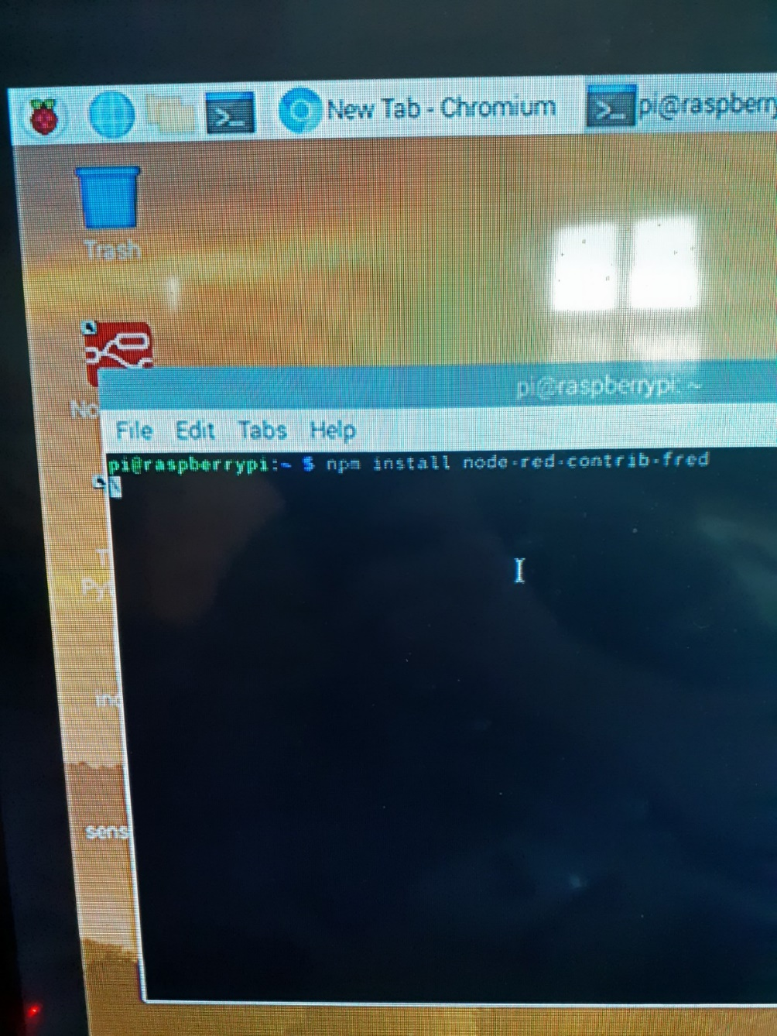

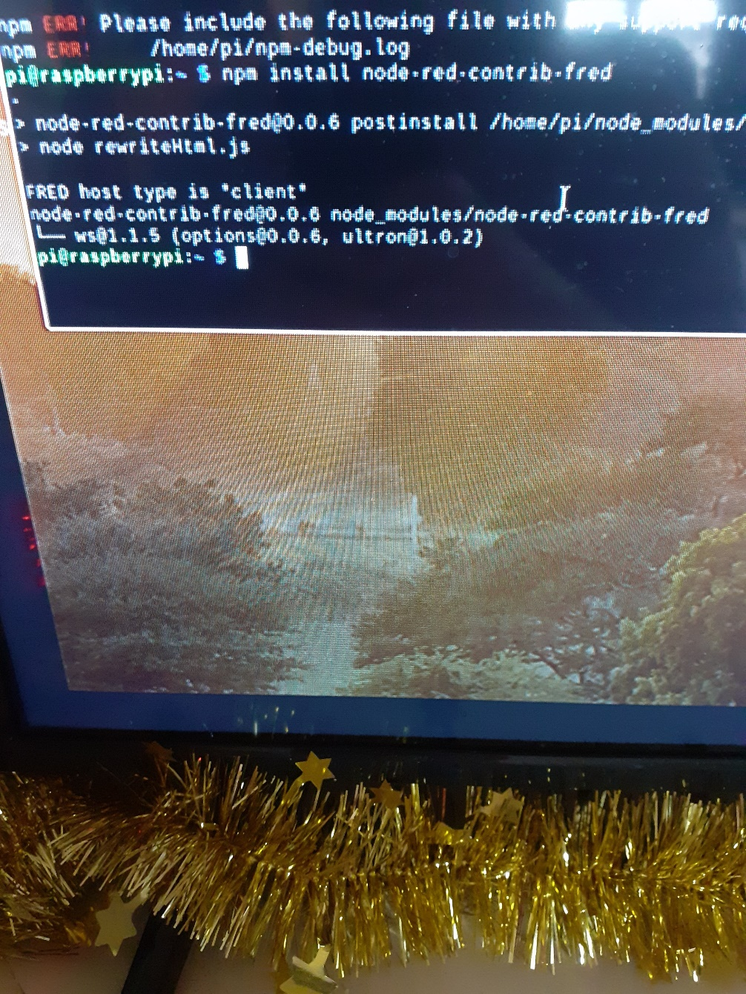

* Next, I went to google and typed “[**http://fredsensetecnic.com**”](http://fredsensetecnic.com) to access the **FRED dashboard** and start my Instance. Then I click “**Start Instance**” and then I will be taken to the **Node-Red FRED Instance** layout.

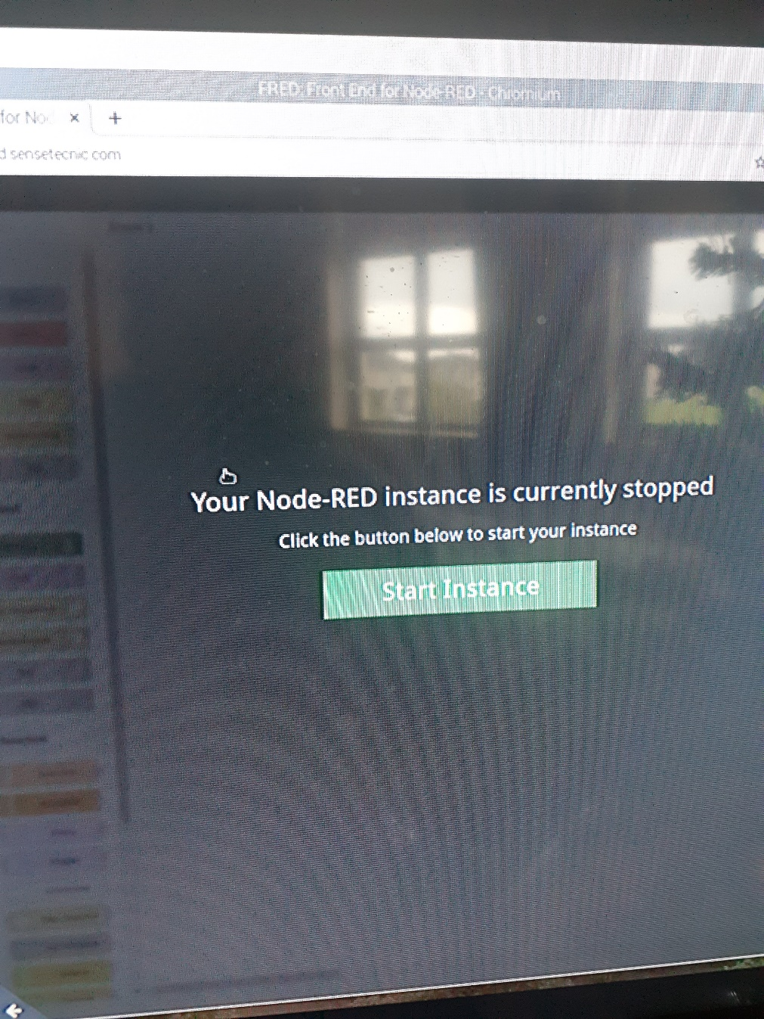

* Now I can move onto **Node-Red** to create the code required for Node-Red to function and **map across** to my FRED Instance from my **Sense-Hat** readings.

**Creating Code for Node-Red:**

* In order to create the Node-red code, I need to firstly install the FRED node from the “**Manage Palette**” section of **Node-Red**. I will navigate to the top right corner of the grid and select the **burger icon** and select “**Manage Palette**”. I will then search for **FRED** in the search bar and select “**node-red-contrib-fred**" and select “**Install**”.

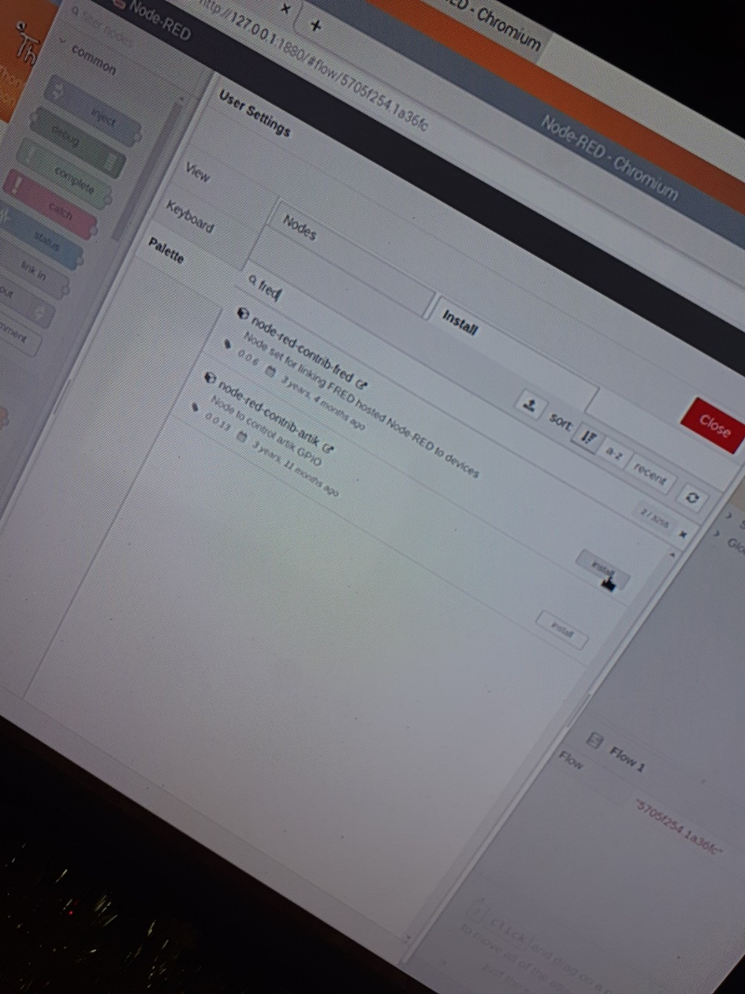

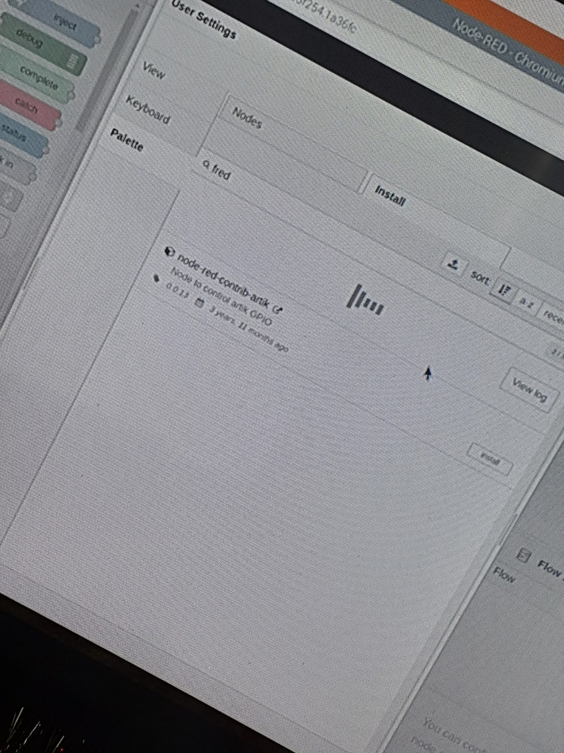

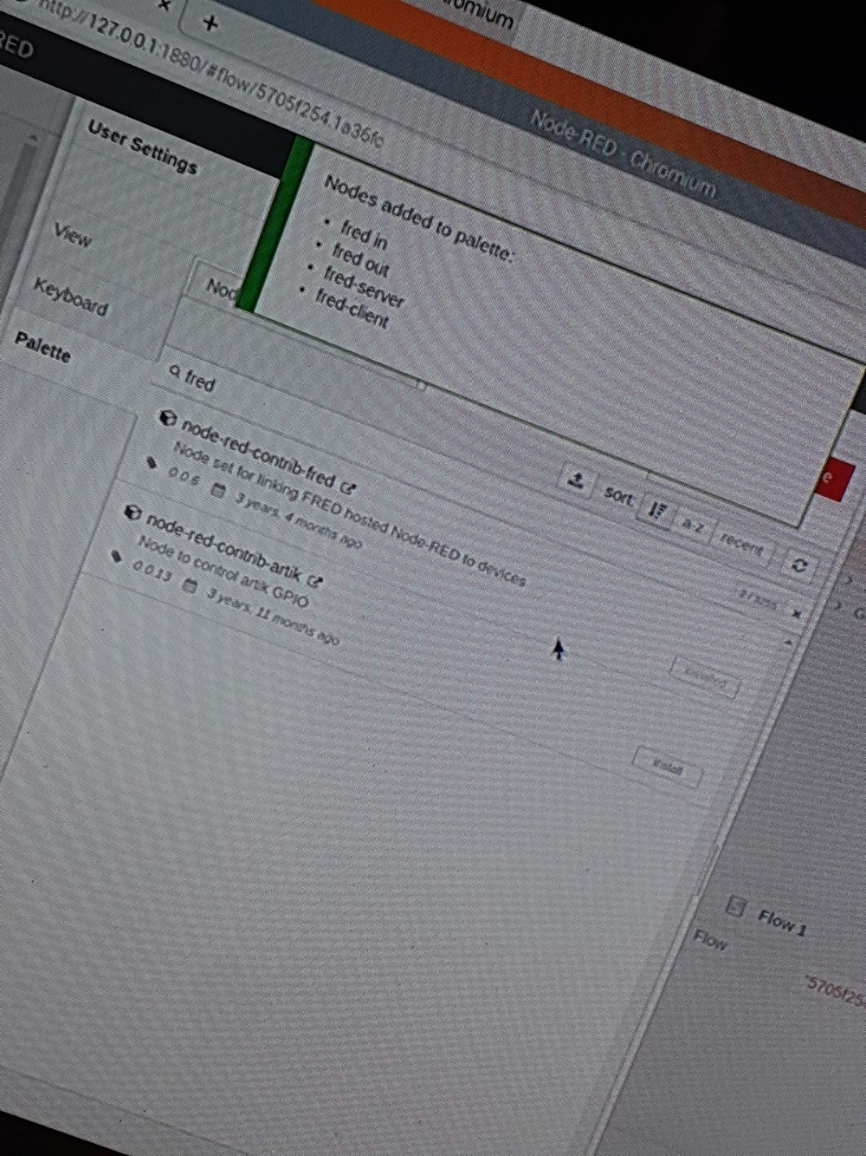

* Now I can view and state that the **FRED nodes** have been successfully added to the “**Filter Nodes**” section on the left side of my screen.

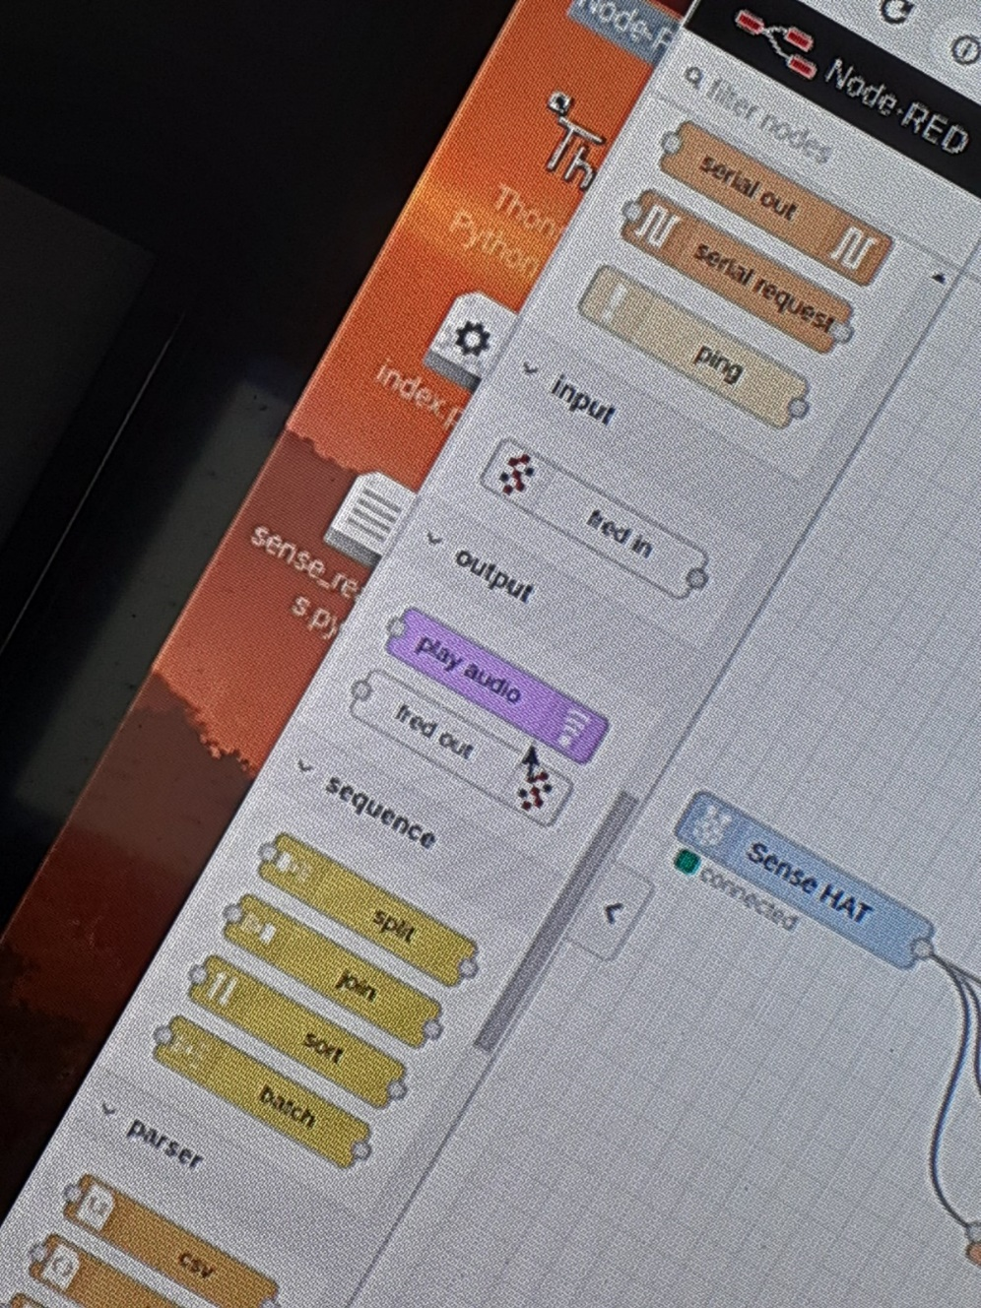

* Next, I need to **import the functions** I created for my **Part B** of my project to use for this section of the project. Once I import the function, I will add the “**FRED Out**” to my Node-Red function to **link it to my FRED function** that I will create later.

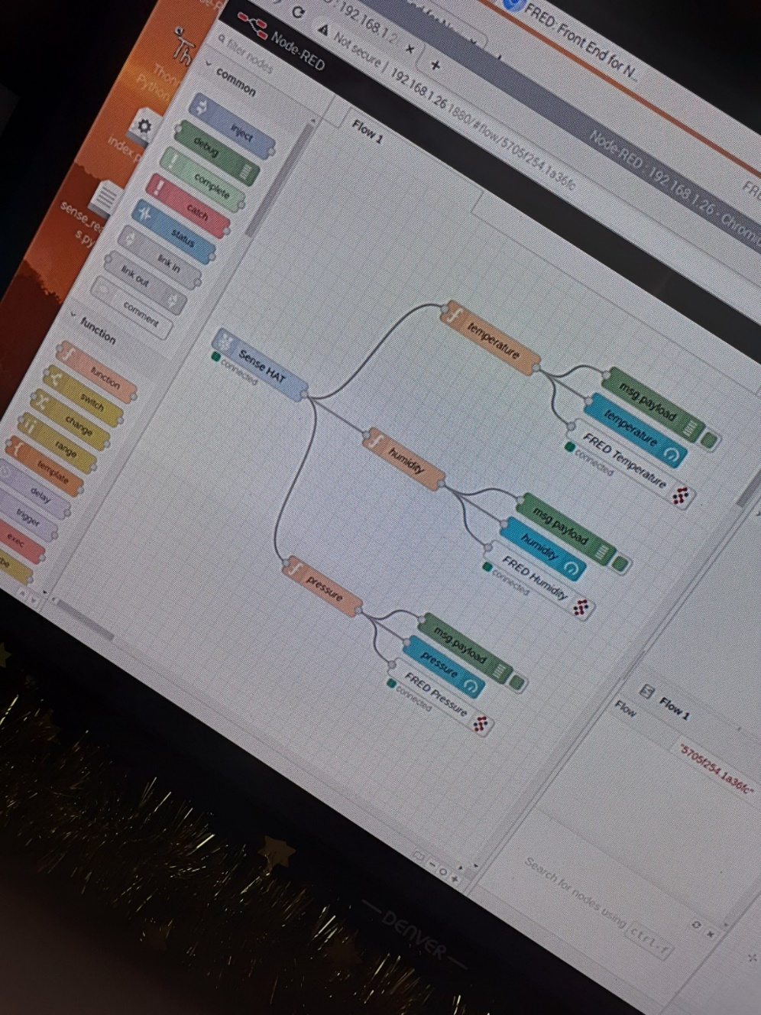

* Now that I have added my **FRED Out** nodes to my function and connected them to their respective function, I will now **create the endpoints** required for each node. To do this, I will click the **little pencil icon** beside the “**Endpoint**” box.

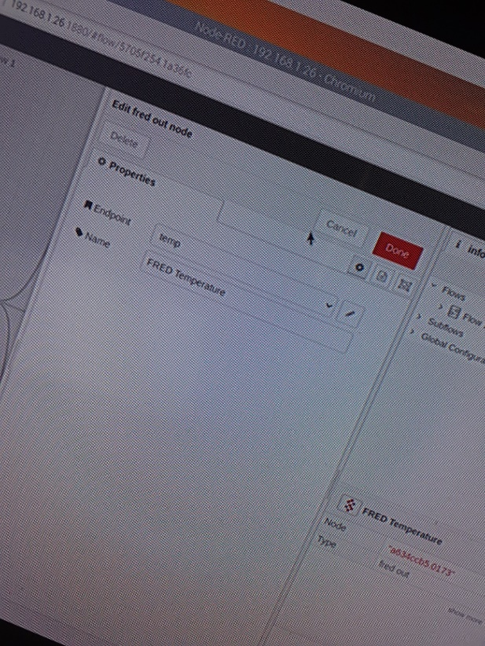 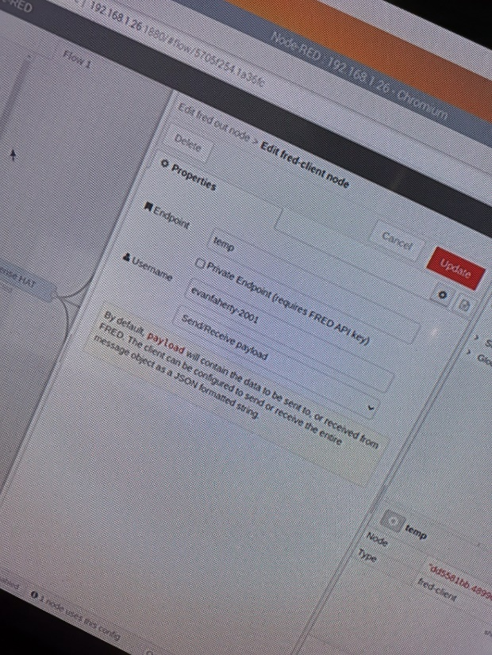

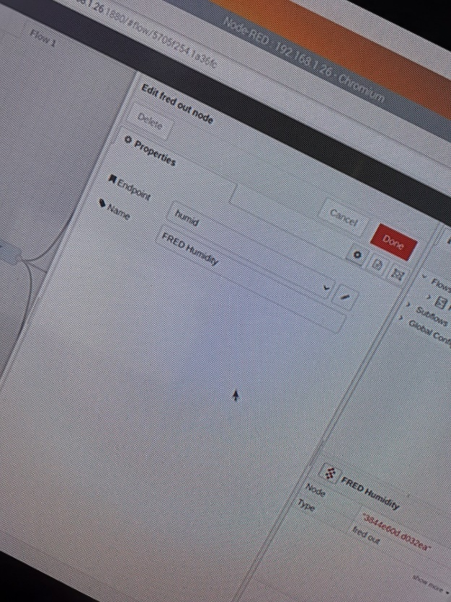 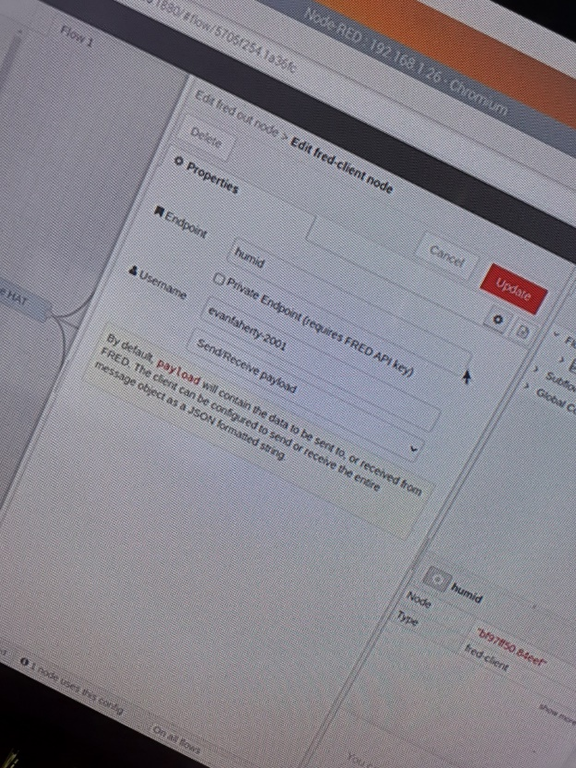

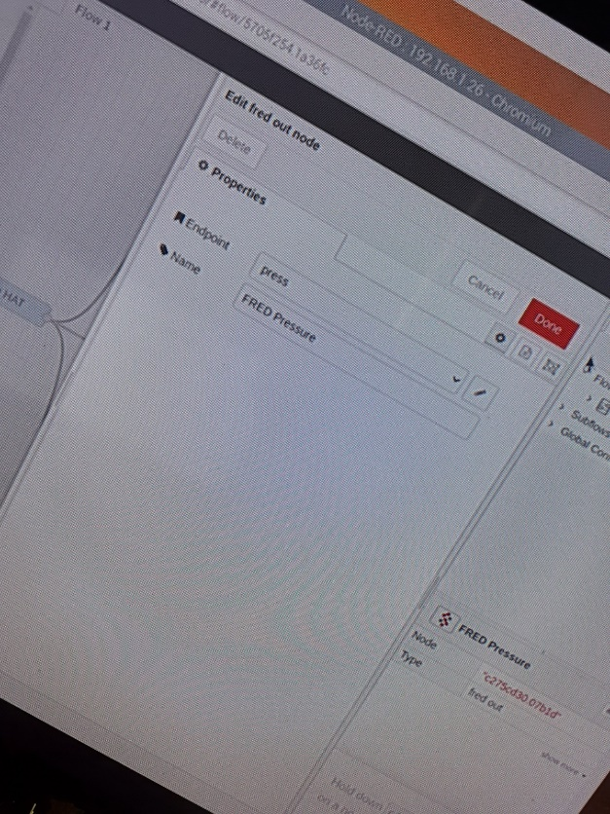 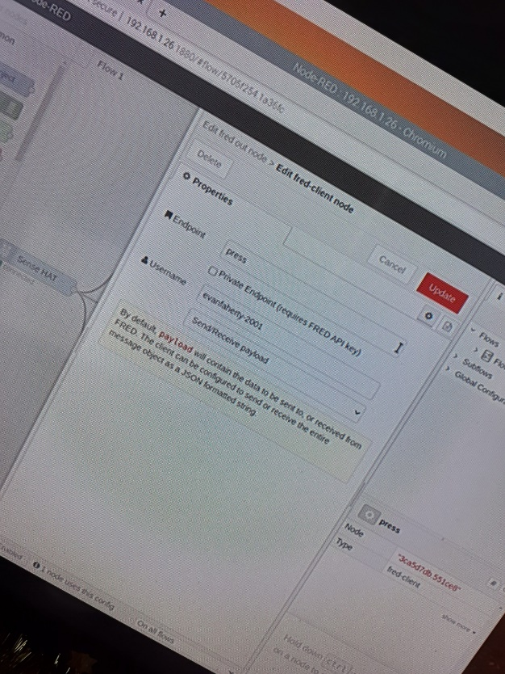

* Now that I have created the Endpoints, I can move on to creating the function for my **FRED function** which is on my **FRED Node-Red** installment.

**Creating Code for FRED:**

* Firstly, I need to go to “[**http://fredsensetecnic.com**”](http://fredsensetecnic.com) to access my FRED function that I will be creating now.

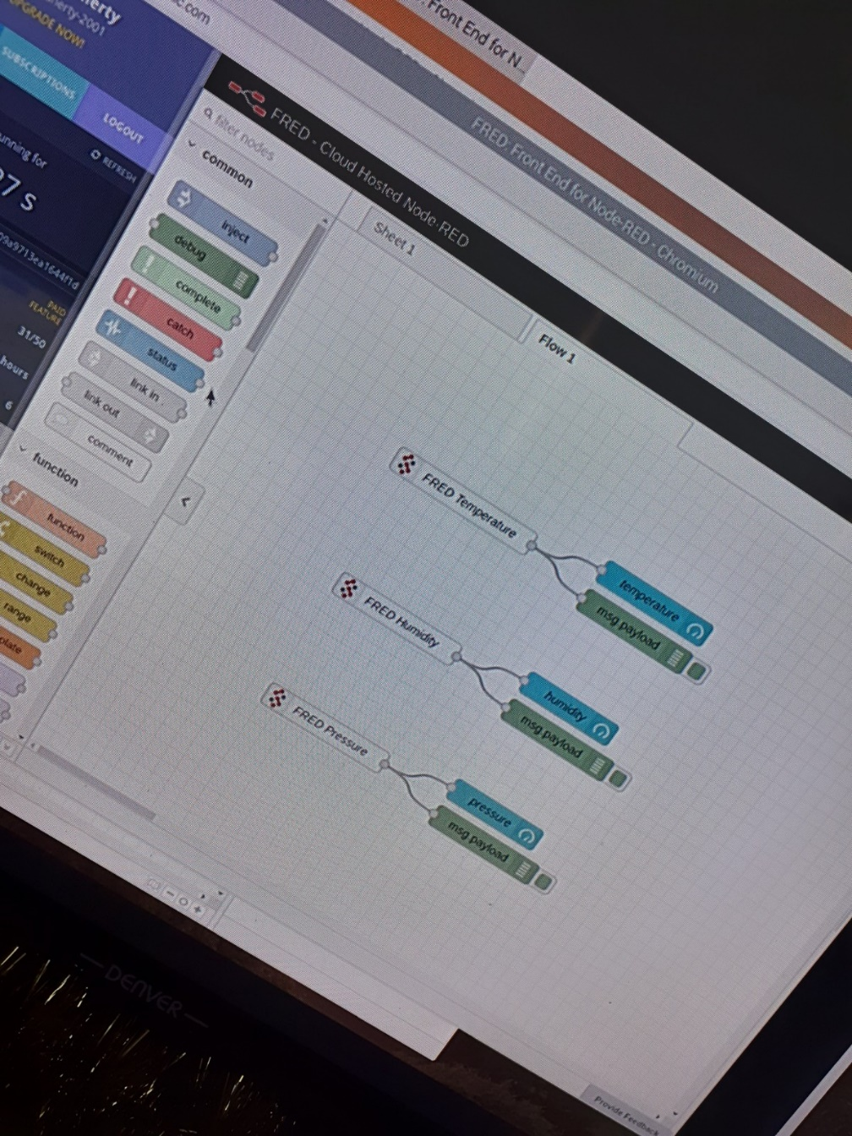

* I will begin by selecting the node “**FRED In**” and using **3 different FRED in** nodes for each of a **temperature, humidity and pressure**.
* I will then **edit the Endpoint** to be able to **connect** the output from this FRED function to the other **Node-Red function** we created previously.

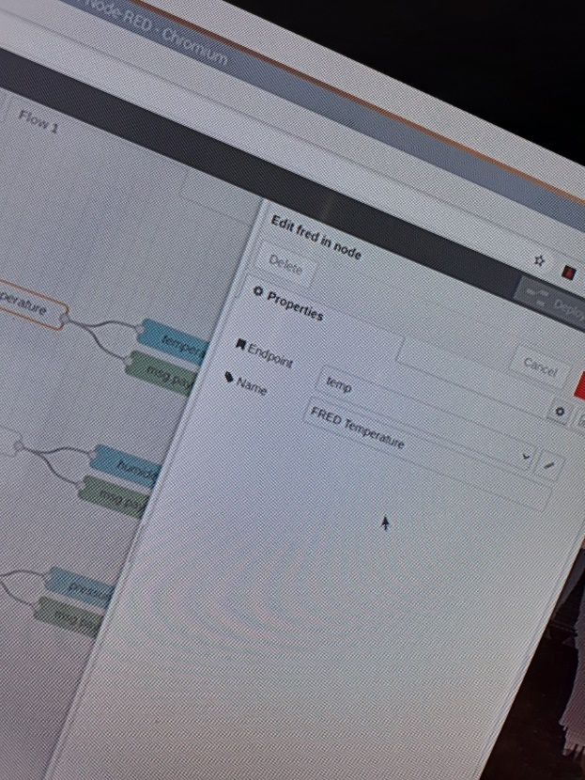 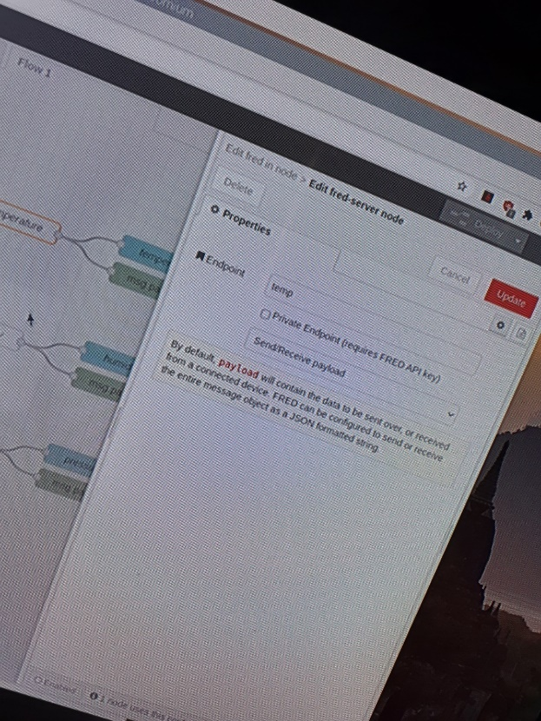

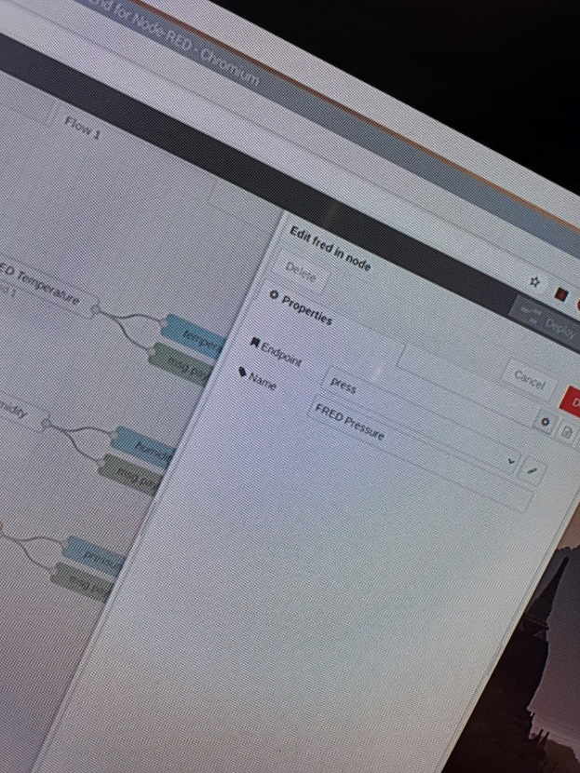 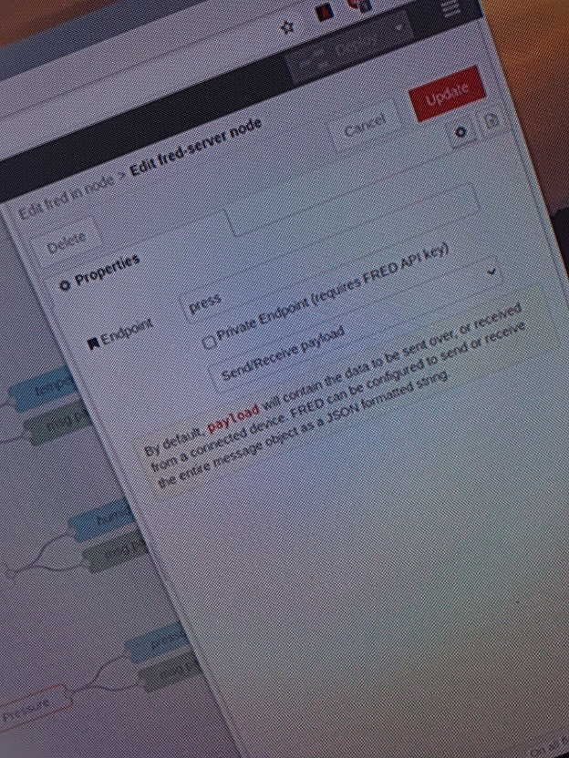

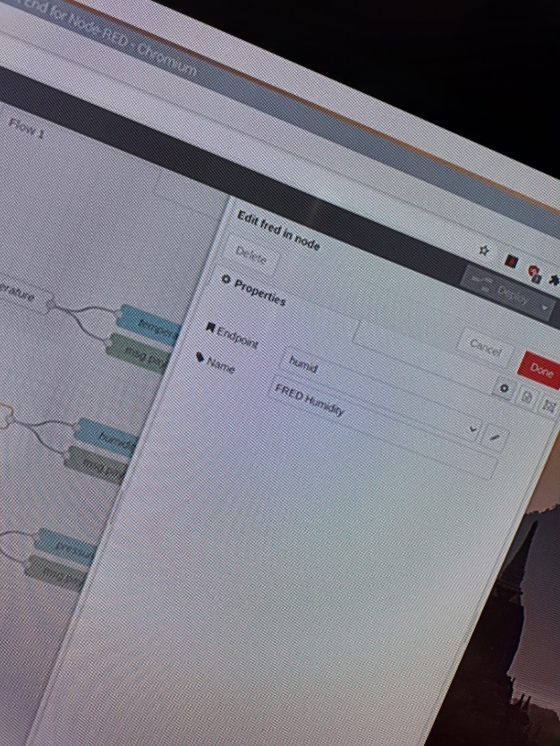 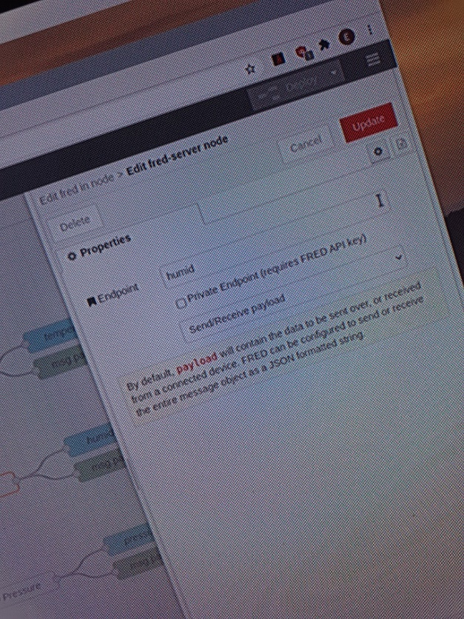

* Now that I have all my **Endpoints named and created** to link back to my **Node-Red function**, I can finally move on to **viewing my data** in a **Web Server window**.

**Displaying Data in Web Server:**

* In order to view my data from **FRED** and my **Raspberry Pi Sense-Hat**, I need to activate the **FRED Public Dashboard in FRED** to view my data.

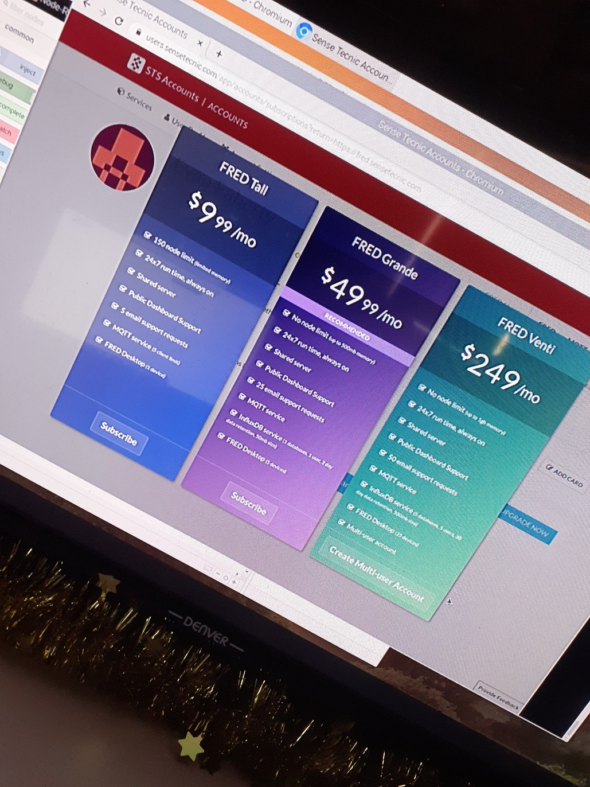

**Conclusion:**

* However, since I only have the **free version of FRED**, I will be unable to demonstrate how the data appears on my Dashboard in my Web Server. If I did have the **full version paid for**, I would be able to **demonstrate and show my recordings** from my **Sense-Hat** on my **browser window**.